The Current Statement of a VR Construction Design APP
(DECO7230)

Basic detail

Full Name: Jiepeng Huang
Student Number: 47352580
Practical Session: 04
Demonstrator Name: Ben Ross

Statement of Originality

I certify that the following used in the current prototype are my own work:

The material for generating the creation: brainstorming records, interview records, and storyboards drawn before.
The media for recording the process: photos and videos.
Some parts of the paper prototype: the wooden house

References for all external resources can be found on page 8 of this document.

The concept

Introduction

Architecture always requires architects to utilize every tool to demonstrate their mind and many professional software are part of popular choices. With the development of software technology, the concepts of computer-aided design (CAD) and Building information modelling (BIM) have become increasingly mature [1]. Meanwhile, there are now many architectural design software available for people to choose from, including 3D software like Revit and Rhino 3D [2].

After upgrading traditional 2D drawings to 3D models, the BIM system shortens the work cycle of architectural design and promotes cross-disciplinary cooperation. Many current research directions are also related to it. Hence, compared to traditional CAD drawing, the BIM system looks more suitable and more in need of the addition of VR technology [3][4].

My concept is exactly based on these previous research and software, which means it would be a 3D construction design software in a VR version. It allows the user to design and interact with the building in an immersive way to better simulate the realization of the building.

In this deco7230 course, for the architectural design VR software I have in mind, I have decided to explore and investigate the following three key tasks:
- the adjustment of the angle of daylight exposure
- the adjustment of the scale zooms
- the movement of the designer

Storyboard

I tried to create a storyboard to show possible interaction and usage scenarios for this app.

Fig 1: The storyboard (part 1) of the construction design app concept.

John, an architect, wanted a more realistic and immersive way to test the buildings he designed, so he chose a VR architectural design app. After choosing the desired terrain, he tried to adjust and place the building in his preferred position using gestures. Finally, by rotating the terrain, he chose the right light path for rendering.

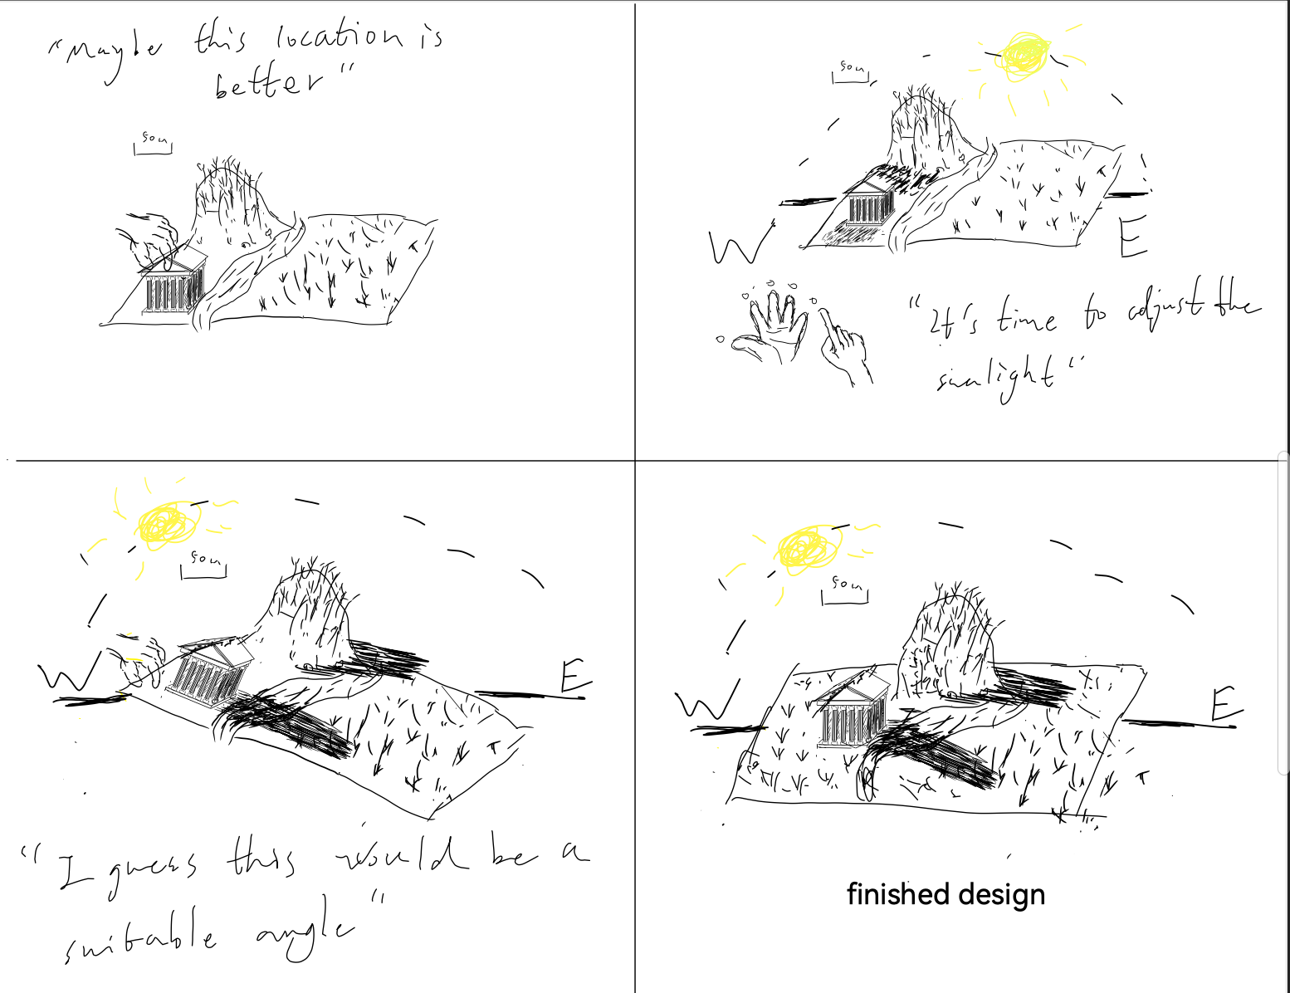
Fig 2: The storyboard (part 2) of the construction design app concept.

Testing Agenda/Protocol

Evaluation Method

In the prototype1 test, the main objective was to collect users' feelings about the whole architectural design application and to test which adjustment interaction is more suitable or acceptable for users under the light adjustment task.

This experiment mainly uses think-aloud and interviews to collect data, while three simple quantitative questions are also designed to be used for analysis in the interviews.

Here are the questions:
Do you think this architecture app design is useful for future users? (1-5)
Could you give a score for the interaction efficiency? (1-5)
Could you give a score for whether the interaction is intuitive or not? (1-5)

The Purpose of this testing round

During the previous design process, I made two scenarios for the light adjustment, so I wanted to gather some feedback from the test and use it to decide which is the better interaction method.

The significance of testing the light adjustment is that it is part of the environment simulation in architectural design, and also many modelling software support the lighting simulation. Therefore, this type of task and interaction should be an essential component in future VR architectural design software.

As mentioned in previous discussions with tutors, a paper model should be focused on the interactive parts it enables and the data it can help collect. Therefore the actual prototype will not be able to include any virtual environments or provide any immersive experience. As the purpose of my experiment lies in the interaction of light adjustments, I don't need any other UI design and should focus on the light-providing subject (the virtual sun) and the light receivers (buildings and terrain).

Participants

Students from the same studio

The Form of the Prototype (Experimental Device)

The prototype is an interactive model, made of paper and wooden boards, including a wooden house, a terrain environment made of cardboard, sunlight acted by a mobile phone flash, and a long wooden board as a sun route.

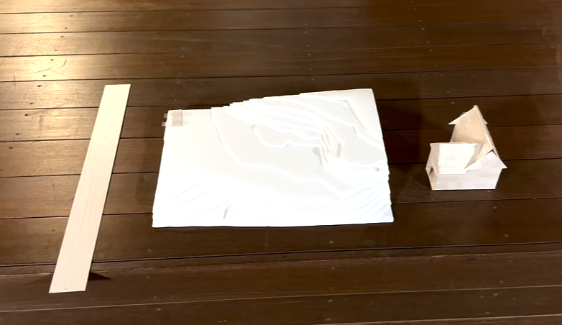
Board Paper Land Wooden House
Fig 3: The components of the paper prototype.

The parts that the user can interact with include moving the paper terrain, rotating the longboard, and placing a building (a wooden house)

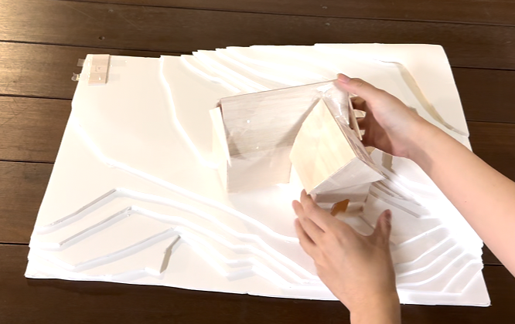
Fig 4: The interaction of placing a house.

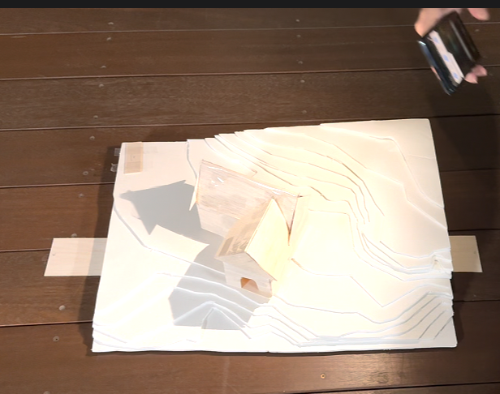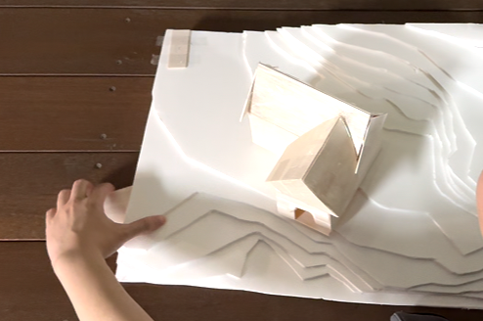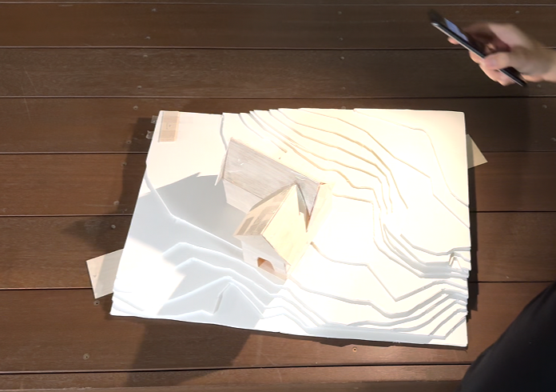
Fig 5: The interaction of light adjustment.

The purpose of the prototype is to allow the user to get a feel for the basic concepts and interactions of the architectural design application while focusing on providing interactions for light routing adjustments to the simulation.

Task

Participants will be asked to try all two interactions, freely adjusting the light through them, and the experimenter will answer any questions about the interaction in the process. Participants will be required to try adjusting the terrain first in order to change the angle, and only after that to try adjusting the light with the interaction planks. At the same time, they will be asked to express their feelings and thoughts throughout the process and will have interviews at the end.

Evaluation Outcomes & Reflection

During the studio class in week 4, I have collected feedback from four volunteers in total. I have graphically presented the results of the three quantitative questions through the code.

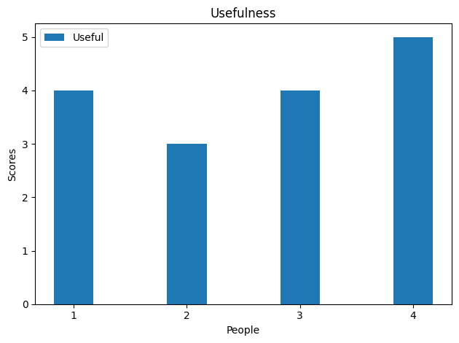
Fig x: The feedback about the usefulness of the entire design.

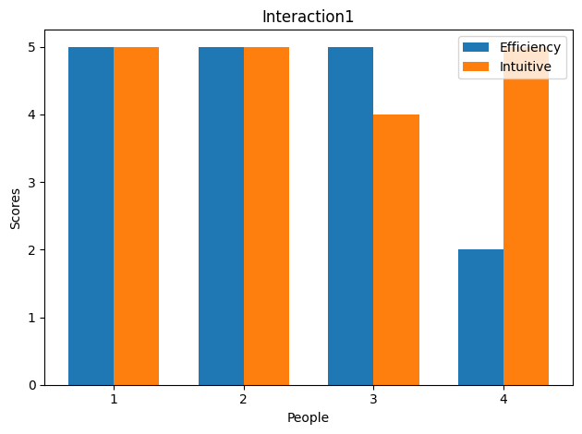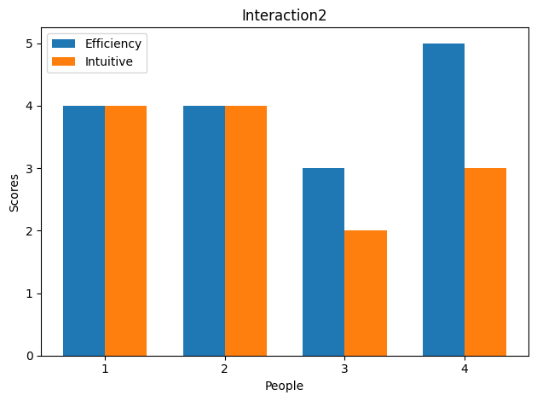
Fig x: The feedback about the feeling of the different light adjustment interactions. One is moving the land and Two is moving the board.

quantitative analysis

The first thing to mention is the satisfaction of the volunteers with the design solutions. They generally agreed that VR architectural design applications are in demand and can be beneficial to architects. The provider with the lowest score seems to be mainly dissatisfied with the lack of functionality, while she also offers many ideas and comments.

The most noteworthy aspect might be the main test direction of this experiment, namely the comparison of the two interaction methods. As the result shown above by figures, the moving ground approach was more popular, scoring high on intuitiveness. However, one volunteer scored it low for efficiency. The moving board interaction generally did not have as good feedback as the moving terrain but received a favourable score from an individual volunteer.

qualitative analysis

think-aloud

In the records obtained through think-aloud, all volunteers expressed satisfaction with the interaction experience that had been set up, with some volunteers saying “feel everything in control”. In addition, after being told that this is an architectural design software, volunteers will try to ask if they can choose different terrains and buildings and will also try more possible interactions by asking related questions.

In experiencing both interactions in turn, while most people supported the interaction of moving the terrain directly, one volunteer pointed out that the ground felt too heavy and uncomfortable. Further, he expected the interaction with the ground to produce more effects than just a change in light angle. Therefore, he would prefer the second type of interaction, adjusting the light through the board.

Interview

Most of what the volunteers said in the post-completion interviews were suggestions for the future of the app, but there was also some explanation of the experience in think-aloud. The volunteer who preferred the board interaction said that he also admitted that the board interaction was not intuitive and that there was no way for the user to interact smoothly without guidance.

Other volunteers preferred moving the terrain to adjust the light, but they offered more suggestions for future application features. These suggestions can be broadly summarized as follows:
1. Allow scale changes
2. allow the import of house models
3. allow selection of different terrain
4. allow in-app house design

Conclusion

The purpose of this experiment was to explore the usability of a VR architectural design application and the options for its light adjustment interactions. Through think-aloud and interviews, we collected data from four volunteers and analysed it in some way. The data collected from the experiment indicates that the interaction style of moving terrain may be more in line with the user's needs, but improvements need to be considered to avoid an uncomfortable experience for the user.

The experiment also generated several useful suggestions, which will be analysed in a future work section.

Testing Plan (Future Work)
Based on the experimental results, VR architectural design applications are a design direction worth realising and continuing to explore. At the same time, there is a need to further improve the light adjustment interaction, the initial idea is to choose to adjust the terrain interaction but add more guides and effects as it gets the best feedback. For the other interactions and features of the application, the next experiments should focus on realising the interactive features of changing the scale and providing a variety of buildings, which is in line with the initial plan.

The plans for prototype 2 and prototype 3 are as follows:
2: Implement the same interactions as the paper model and allow scale changes
3: Allow changes to buildings and terrain

Electronic Journal Link

https://drive.google.com/drive/folders/1dBvjtcIOuqX4Q7XEFmfbn2m3r2t8CHVt?usp=drive_link

Video Link to The Prototype

https://youtu.be/pe3kGJQ0xqE

Reference

[1] Johnny Kwok, Wai Wong, Jason Zhou, “Enhancing environmental sustainability over building life cycles through green BIM: A review”, Automation in Construction, Volume 57, 2015, Pages 156-165, ISSN 0926-5805, https://doi.org/10.1016/j.autcon.2015.06.003.

[2] 3DSOURCED, “10 Best 3D Architecture Design Software in 2024”, (https://www.3dsourced.com/3d-software/best-architecture-software-design/)

[3] Ahmed M.M. Hasan, Ahmed A. Torky, Youssef F. Rashed, “Geometrically accurate structural analysis models in BIM-centered software”, Automation in Construction,
Volume 104, 2019, Pages 299-321, ISSN 0926-5805, https://doi.org/10.1016/j.autcon.2019.04.022.

[4] Rostamiasl V, Jrade A (2024). “A cloud-based integration of Building Information Modeling and Virtual Reality through game engine to facilitate the design of Age-in-Place homes at the conceptual stage”, ITcon Vol. 29, pg. 377-399, https://doi.org/10.36680/j.itcon.

The paper land part of the paper prototype was borrowed from a friend who was an architecture student.

